

task 10

DBMS



May 25, 2023

AKHTAR ALI

34241

|  |
| --- |
| ALL QUIRIES |
| select ename,sal,grade from emp,salgrade where emp.sal>2000; |
| select ename,sal,grade,hisal,losal from emp,salgrade where emp.sal between losal and hisal; |
| select ename,sal,grade from emp join salgrade on (sal between losal and hisal); |
| select e.ename,m.ename manager from emp e,emp m where e.mgr=m.empno; |
| select e.ename,m.ename manager from emp e,emp m where e.mgr=m.empno order by m.ename; |
| insert into emp(empno,ename) VALUES (222,'noman'); |
| insert into dept(deptno,dname) values(80,'SE'); |
| commit; for reset/restore |
| select ename,dname from emp,dept where emp.deptno=dept.deptno; |
| select ename,dname from emp,dept where emp.deptno=dept.deptno(+); |
| select ename,dname from emp,dept where emp.deptno(+)=dept.deptno; |
| select ename,dname from emp,dept where emp.deptno=dept.deptno(+)  2 union  3 select ename,dname from emp,dept where emp.deptno(+)=dept.deptno; |

* Query#1: select ename,sal,grade from emp,salgrade where emp.sal>2000;

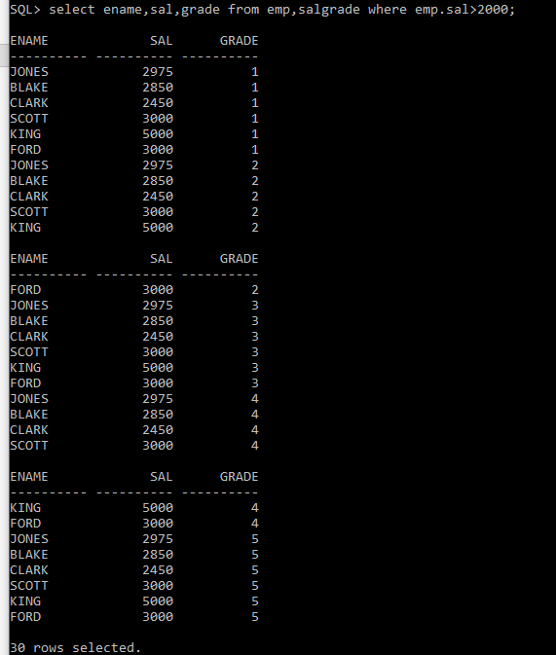

* Query#2: select ename,sal,grade,hisal,losal from emp,salgrade where emp.sal between losal and hisal;

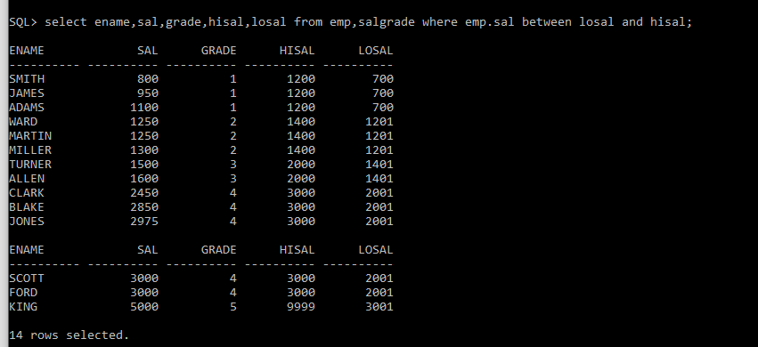

* Query#3: select ename,sal,grade from emp join salgrade on (sal between losal and hisal);

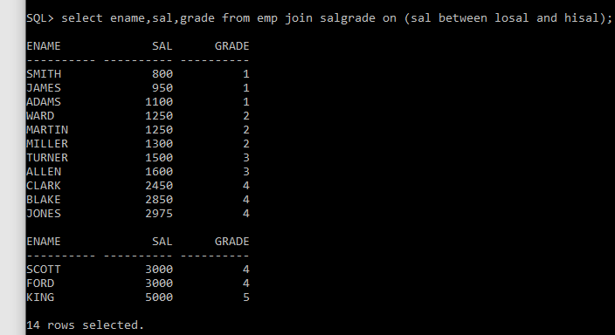

* Query#4: select e.ename,m.ename manager from emp e,emp m where e.mgr=m.empno;

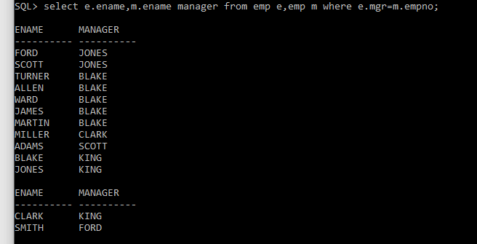

* Query#5: select e.ename,m.ename manager from emp e,emp m where e.mgr=m.empno order by m.ename;

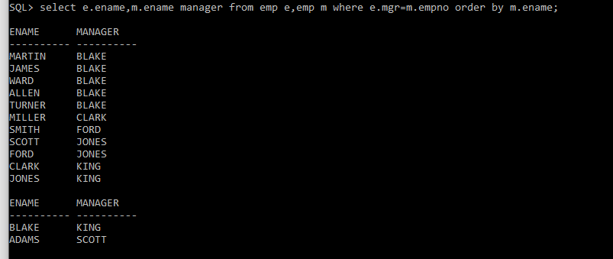

* Query#6: insert into emp(empno,ename) VALUES (222,'noman');

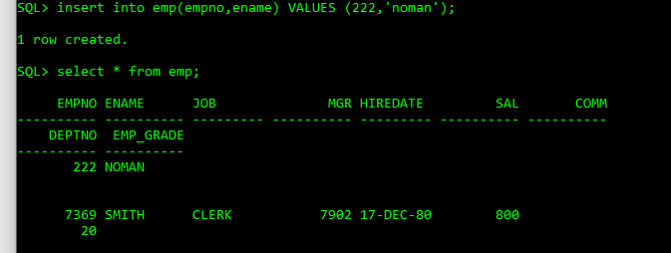

* Query#7: insert into dept(deptno,dname) values(80,'SE');

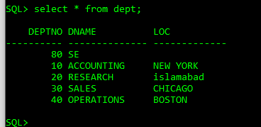

* Query#8: select ename,dname from emp,dept where emp.deptno=dept.deptno;

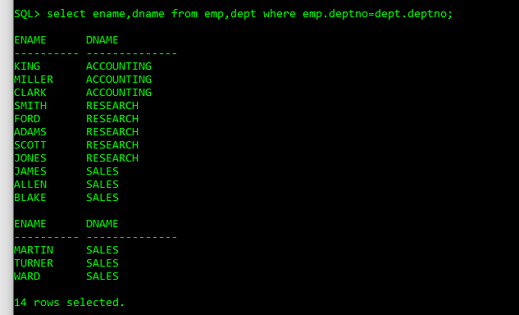

* Query#9: select ename,dname from emp,dept where emp.deptno=dept.deptno(+);

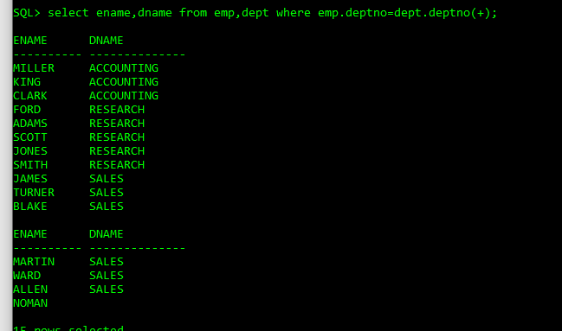

* Query#10: select ename,dname from emp,dept where emp.deptno(+)=dept.deptno;

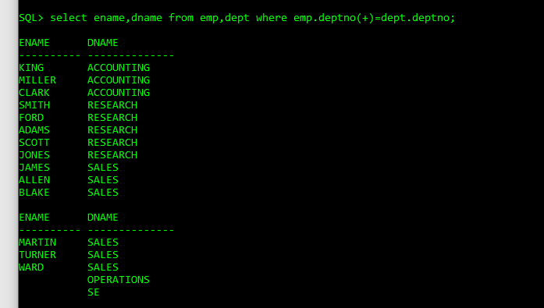

* Query#11: select ename,dname from emp,dept where emp.deptno=dept.deptno(+)

union

select ename,dname from emp,dept where emp.deptno(+)=dept.deptno;

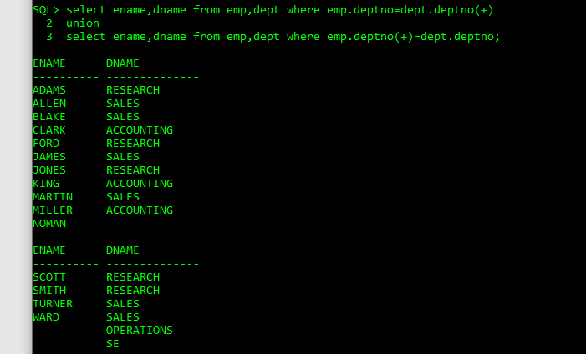

* Query#12: